**Progress report 15**

Tawab Karim

|  |  |
| --- | --- |
| Date | 15/01/2019 |
| Subject | AIM |
| Project Term |  |

# Outcomes of the last meeting (17/12/2019)

* First we will write something about de TIRF setup and B-splines. We want to introduce the microscope onto the website in a structured manner.
* Maybe combine multiple labs onto the same website, while we might have not enough material to keep the website interesting enough.
* Design error in laserbox, there were no pre tapered holes in the side of the struts. Nisse will add these.
* Use 640 nm laser for light sheet. 2um thickness. Need to select different optical components, while I hadn’t taken in account that the system is currently diffraction limited. I can play around with the parameters in ZEMAX in order to optimize this.
* Nisse hasn’t started with the production of batch-4 yet, while delivery date was promised to be 10/01. Current delivery date is set end of February. (This is due to the fact that there are going to be a lot of reorganization while all departments pay a contribution but not all departments feel like they can produce there. This caused some friction, so there will be an overhaul in how things are going to be done)

# Results during the last week(s)

* Finished the global design of the website, currently only content is needed.
* Calculations done on AIM, diffraction limited system. New calculations needed and new optical components are thus needed.

# Other business

* -

# Plans for next week(s)

* Make list of to-do’s for content on the website
* Create new optical design for lighsheet using zemax to optimize

# Schedule current and next week

## This week

* Monday 0900-1500
* Wednesday 1400-1700
* Friday 1000-1800

## Next Week

* Wednesday 1300-1800

|  |  |  |  |  |
| --- | --- | --- | --- | --- |
| Project | Figure | Current Components | Needed Components | Earliest Due Date |
| DMD-Setup | LINK |  |  |  |
| TIRF-Setup | LINK | 1,2,3,4,6,7,8,10 | 5,9 | 30/09/2019 |
| LS-Module | LINK |  |  |  |

## 

|  |  |  |  |  |  |
| --- | --- | --- | --- | --- | --- |
| Figure no. | Component code | Component Name | Amount in Inventory | Amount in production | Production due date |
| 1 | CR001-A | Microscope Tower | 1 | 2 | 30/09/2019 |
| 2 | CR002-A | EM Plate | 1 | 2 | 30/09/2019 |
| 3 | CR003-A | FilterPlate | 1 | 2 | 30/09/2019 |
| 4 | CR004-A | CoverPlate V2 P1 | 1 | 2 | 30/09/2019 |
| 5 | CR005-A | CoverPlate V2 P2 | 0 | 3 | 30/09/2019 |
| 6 | CR006-A | BottomPlate | 1 | 2 | 30/09/2019 |
| 7 | CR007-A | Stage Mount | 3 | 0 | - |
| 8 | CR008-A | Stage Plate | 3 | 0 | - |
| 9 | CR009-A | Tube Lens Mount | 0 | 1 | 18/10/2019 |
| 10 | PP001-A | CameraMount | 2 | 0 | - |
| 11 | CR008-B | Stage Plate | 0 | 1 | 18/10/2019 |
| 12 | CR010-A | StageThorlabsAdapter-A | 0 | 1 | 18/10/2019 |
| 13 | CR011-A | StageThorlabsAdapter-B | 0 | 1 | 18/10/2019 |
| 14 | CR012-A | SpacerBlockStage | 0 | 1 | 18/10/2019 |
| 15 | CR013-A | FilterPlateStraight | 0 | 1 | 18/10/2019 |
| 16 | CR020-A | PanelLaserBox1 | 0 | 1 | 04/10/2019 |
| 17 | CR021-A | PanelLaserBox2 | 0 | 1 | 04/10/2019 |
| 18 | CR022-A | PanelLaserBox3 | 0 | 1 | 04/10/2019 |
| 19 | CR023-A | PanelLaserBox4 | 0 | 1 | 04/10/2019 |
| 20 | CR024-A | PanelLaserBox5 | 0 | 1 | 04/10/2019 |
| 21 | CR025-A | PanelLaserBox6 | 0 | 1 | 04/10/2019 |
| 22 | CR026-A | PanelLaserBox7 | 0 | 1 | 04/10/2019 |
| 23 | CR027-A | PanelLaserBox8 | 0 | 1 | 04/10/2019 |
| 24 | CR028-A | PanelLaserBox9 | 0 | 1 | 04/10/2019 |
| 25 | CR029-A | PanelLaserBox1D | 0 | 1 | 04/10/2019 |
| 26 | CR030-A | PanelLaserBox4D | 0 | 1 | 04/10/2019 |
| 27 | CR014-A | OuterBlock1 | 0 | 1 | 31/01/2020 |
| 28 | CR015-A | OuterBlock2 | 0 | 1 | 31/01/2020 |
| 29 | CR016-A | InnerBlock | 0 | 1 | 31/01/2020 |
| 30 | CR017-A | PolerazationConnector | 0 | 1 | 31/01/2020 |
| 31 | CR018-A | PolerazationSelector | 0 | 1 | 31/01/2020 |
| 32 | CR031-A | BackPlateMirror | 0 | 0 | - |
| 33 | CR032-A | MirrorRotMount | 0 | 0 | - |
| 34 | CR033-A | HoldPlate | 0 | 0 | - |
| 35 | CR034-A | Mounting | 0 | 0 | - |
| 36 | CR035-A | SidePlateConnector | 0 | 0 | - |
| 37 | CR036-A | SidePlateB | 0 | 0 | - |
| 38 | CR037-A | SidePlates | 0 | 0 | - |
| 39 | CR038-A | NemaMount | 0 | 0 | - |
| 40 | CR039-A | HaltePlatte | 0 | 2 | 31/01/2020 |
| 41 | CR040-A | Anschraubplatte | 0 | 2 | 31/01/2020 |
| 42 | CR041-A | Kugelhalter2 | 0 | 4 | 31/01/2020 |
| 43 | CR042-A | Kugelhalter | 0 | 2 | 31/01/2020 |
| 44 | CR043-A | Kugelhalter3 | 0 | 2 | 31/01/2020 |
| 45 | CR044-A | BasePlateStage | 0 | 1 | 10/01/2020 |
| 46 | CR045-A | MountingPlate | 0 | 2 | 10/01/2019 |
| 47 | CR046-A | StepConnectPlate | 0 | 1 | 10/01/2019 |
| 48 | CR047-A | BackPlateMirror | 0 | 1 | 10/01/2019 |
| 49 | CR048-A | HoldPlate | 0 | 1 | 10/01/2019 |
| 50 | CR049-A | MirrorRotMount | 0 | 1 | 10/01/2019 |
| 51 | CR050-A | Mounting | 0 | 1 | 10/01/2019 |
| 52 |  |  |  |  |  |
| 53 |  |  |  |  |  |
| 54 |  |  |  |  |  |
| 55 |  |  |  |  |  |
|  |  |  |  |  |  |
|  |  |  |  |  |  |
|  |  |  |  |  |  |
|  |  |  |  |  |  |
|  |  |  |  |  |  |
|  |  |  |  |  |  |
|  |  |  |  |  |  |
|  |  |  |  |  |  |
|  |  |  |  |  |  |
|  |  |  |  |  |  |
|  |  |  |  |  |  |

## Project figures

|  |
| --- |
| DMD-Setup |
|  |
| TIRF-Setup |
|  |
| LS-module |
| -image not yet made- |

## Component figures

|  |  |
| --- | --- |
| Figure 1 -- CR001-A | Figure 2 – CR002-A |
|  |  |
| Figure 3 – CR003-A | Figure 4 – CR004-A |
|  |  |
| Figure 5 – CR005-A | Figure 6 – CR006-A |
|  |  |
| Figure 7 – CR007-A | Figure 8 – CR008-A |
|  |  |
| Figure 9 – CR009-A | Figure 10 – PP001-A |
|  |  |
| Figure 13 – CR008-B | Figure 12 – CR010-A |
|  |  |
| Figure 13 – CR011-A | Figure 14 – CR012-A |
|  |  |
| Figure 15 – CR013-A | Figure 16 – CR020-A |
|  |  |
| Figure 17 – CR021-A | Figure 18 – CR022-A |
|  |  |
| Figure 19 – CR023-A | Figure 20 – CR024-A |
|  |  |
| Figure 21 – CR025-A | Figure 22 – CR026-A |
|  |  |
| Figure 23 – CR027-A | Figure 24 – CR028-A |
|  |  |
| Figure 25 – CR029-A | Figure 26 – CR030-A |
|  |  |
| Figure 27 – CR014-A | Figure 28 – CR015-A |
|  |  |
| Figure 29 – CR016-A | Figure 30 – CR017-A |
|  |  |
| Figure 31 – CR018-A | Figure 32 – CR031-A |
|  |  |
| Figure 33 – CR032-A | Figure 34 – CR033-A |
|  |  |
| Figure 35 – CR034-A | Figure 36 – CR035-A |
|  |  |
| Figure 37 – CR036-A | Figure 38 – CR037-A |
|  |  |
| Figure 39 – CR038-A | Figure 40 – CR039-A |
|  |  |
| Figure 41 – CR040-A | Figure 42 – CR041-A |
|  |  |
| Figure 43 – CR042-A | Figure 44 – CR043-A |
|  |  |
|  |  |
|  |  |
|  |  |
|  |  |
|  |  |
|  |  |

# Appendix

### 

### 

### 

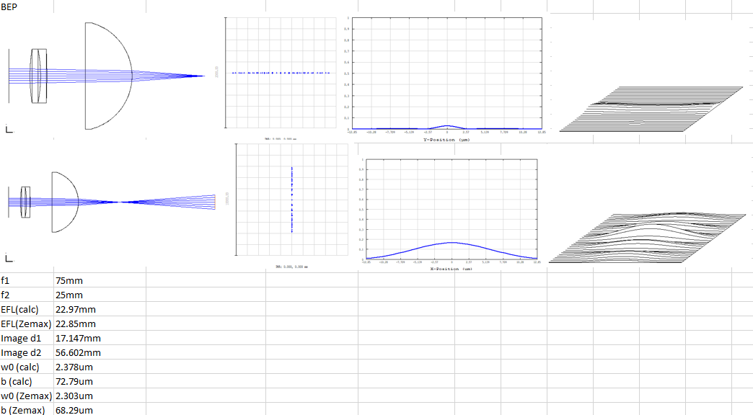

This is a summary of the simulations done with the components that the BEP group used. Looking at both focal distances of the light sheet. Hand calculations roughly match the simulations done in ZEMAX. The top row shows the first focal line of the light sheet and the second row shows the second focal line of the light sheet. From left to right, the setup, the dot diagram, the PSF cross section and the 3D PSF are shown.

This system has been compared to the inverted BEP setup, while the cilindrical lens is recommended to put the other way around. Results are shown below.

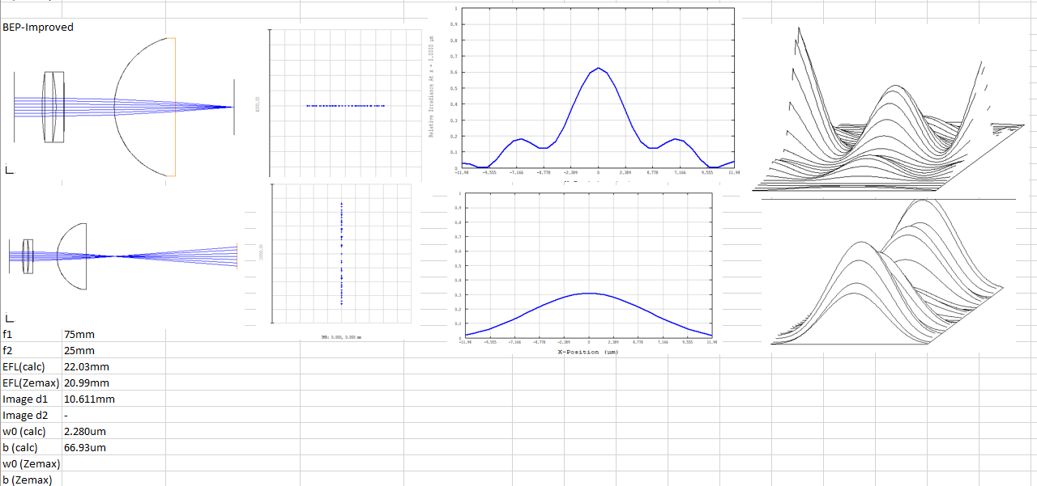

These two are compared to the AIM light sheet.

